**Setting up a project in Netbeans**

1. On the File menu, select New Project

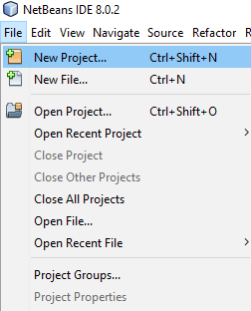

1. On the New Project UI, select Java as the Categories and Java Application as the Projects, click Next

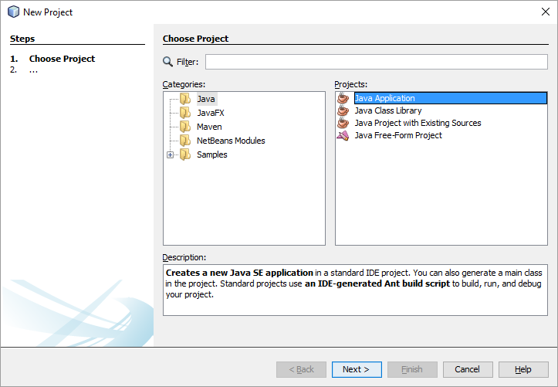

1. On the New Java Application UI, enter the Project Name Othello, ensure that Create Main Class is checked, click Finish

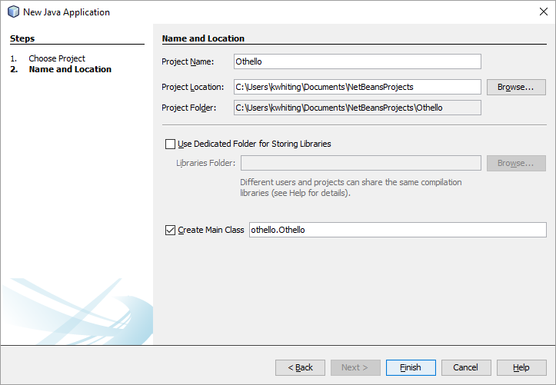

1. This should display in your Projects tab in Netbeans.

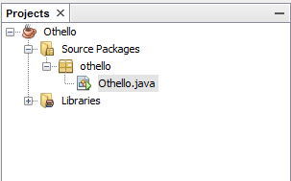

1. To create a new package, right click the Source Packages folder, select New, select Java Package

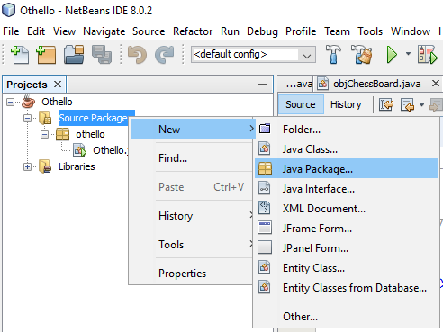

1. On the New Java Package UI, enter the name of the package, click Finish.

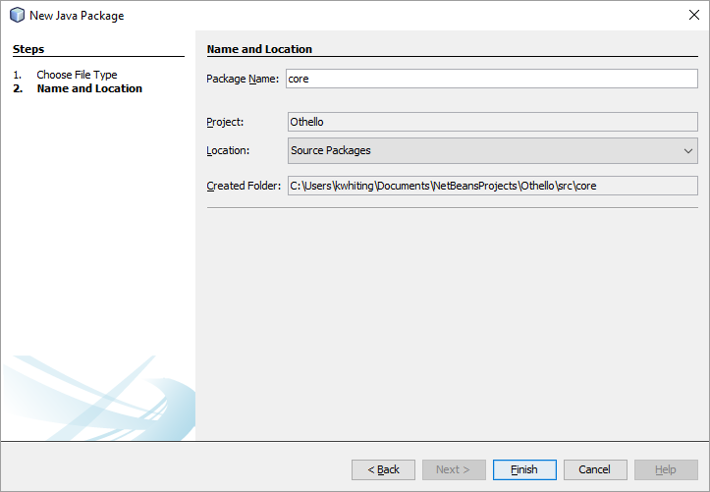

1. To create a new class, right click the package the class will be part of, select New, select Java Class

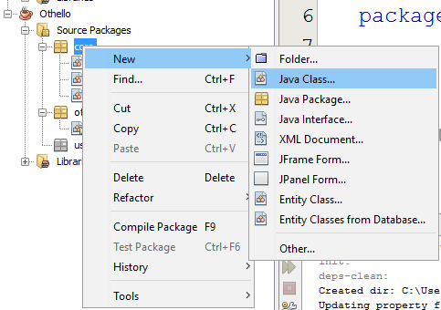

1. On the New Java Class UI, enter the Class Name, click Finish.

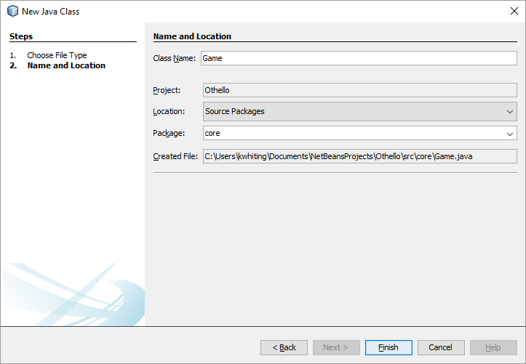

1. The new class will show up in the correct package.

